Preface

This User Guide explains how to use the system to process participated deals. It assumes that you are familiar with the basic principles of trade finance relating to participated deals, and with web browsers.

# About Participated Deals

Trade Innovation supports participation deals, whereby several banks share between them the credit risk of one bank's transactions, or of a given customer's transactions, up to an agreed total commitment amount. In return for sharing the risk, participant banks share the interest or commission payable on these participated transactions. Participation enables banks to limit the proportion of their assets that is tied up in risk to one customer. The system supports participations sold where your bank is the managing bank that sets up and administers the participation deal. Your bank can define a charge for setting up the deal and take the charge periodically, reflecting how much of the agreed total amount is used or unused at that time. One-off charges can also be levied.

Participation deals may be:

* One-off agreements, whereby banks agree to participate in one specific transaction only. These do not need to be created in advance, but can be created when the transaction is created or when liability is maintained
* Pre-determined agreements between banks and a customer. The managing bank sets up a deal in advance, specifying the details of each participant's share of the risk and the charging structure to be used. This deal can then be applied to any number of transactions for the specified customer, up to an agreed total amount

You can specify that a transaction is to be participated either at the time that the transaction is created, or (except for financing transactions) at a later stage, such as when amending the transaction. At any of these stages, you can either select an existing agreed participation deal, or create a new deal.

For example, an import letter of credit might originally be issued for a relatively small amount that the bank is able to cover. An amendment to the amount of the letter of credit might then cause the amount of the credit to exceed the limit that the issuing bank is prepared to risk on its own. The issuing bank might then decide to participate out all or part of the risk to a group of participating banks that have agreed to share the risk for transactions with the relevant applicant.

Participation deals can be revolving. In a revolving participation deal, the commitment amount available is increased, up to the originally agreed total commitment amount, whenever participated transactions are paid, cancelled, or expired, or the amount of the transaction is decreased. For example, if a participation deal is agreed to a total value of 1,000,000 USD and it is applied to two transactions of 350,000 USD each, the amount available is reduced to 300,000 USD. If one of the participated transactions is subsequently paid off, the amount available under the participation deal would stay at 300,000 USD if the deal is not revolving, but would rise to 650,000 USD under a revolving participation deal.

The events used to handle revolving participation deals and drawdowns may be generated automatically against the participation deal, or may need to be entered manually, depending on your bank's internal procedures. Your bank can flag each participation deal as requiring either automatic or manual processing as it is created. Participation deals requiring manual processing are termed manual participation deals in this guide.

Bank-definable fields can be set up for the Create event to indicate that a participation deal is, for example, funded or unfunded or confirmed, or has purchase of claim.

## Transactions that Support Participation Deals

Participation deals can be applied to the following products:

* Import letters of credit, standby letters of credit and guarantees
* Export letters of credit, standby letters of credit and guarantees
* Financing transactions (including Supply Chain Finance, Invoice financing)
* Clean bankers acceptances

1. Transfer letters of credit and revolving letters of credit cannot be participated.

You can specify that a transaction is to be participated:

* For a financing transaction, in the event that creates the transaction
* For a clean banker's acceptance, in the Create event
* For Supply Chain Finance, Invoice Finance deals; when the participation deal is created or when a buyer or seller centric finance deal is created
* In other cases, either when the transaction is created, or later when using a Maintain Liability event

Your bank can participate the risk and interest on loans if you have the financing module installed. If this module is not installed, you can participate the funding and charges of a transaction, but you cannot use the system to split risk management and interest with the participants. It is therefore recommended that you participate only loans created using the financing module.

## Charges and Interest

Charges can be levied when a participation deal is set up. They may be periodic charges, meaning that they are taken at regular intervals over the life of the deal. Your bank can:

* Collect periodic charges either in advance or in arrears of the charging period
* Share the charges paid by the customer between your bank's own charge account and the participant banks' accounts
* Specify that charges are split between these accounts either according to the bank's charge schedule, or using a participant's own deal-specific schedule
* Use the standard charges functionality to display participants' charges
* Set up charge schedules for different charge types, to cater for the use of the participation deal with different trade finance products
* Define participants' own charge schedules when creating a participation deal. This enables participant banks to use a different charge structure from that used by your bank. Therefore, different participants' fees may not be proportional to their share of the risk
* Pay out a commission to a party who is not a participant, but may be an administrative agent
* Charge for the utilised or unutilised portion of the deal commitment amount
* Share the interest due on loans with participants
* Obtain refunds of charges paid in advance to banks who cease to be participants in a participation deal, or who reduce their share; or waive the right to such refunds

See the System Tailoring User Guide – Trade Innovation and the Common Facilities User Guide – Trade Innovation for information on the system's standard charges facilities, including schedules and periodic charges.

### Taking Charges

Where the charges for participation deals are periodic charges, a Pay Charges event is required to take the charges. If the periodic charge has been defined as taken in advance, the first charge will appear in the charges window for taking on confirmation of the transaction in the Create Participation Deal event. To take subsequent charges, and to take the first charge if it is taken in arrears, the system automatically sets up a Pay Charges event as a diary action to occur on the next date that the periodic charge is due. This event re-calculates the charges for the period and makes the necessary postings. Depending on how your bank has defined the Pay Charges event, it may need to be reviewed like any other event.

See the Common Facilities User Guide – Trade Innovation for the Pay Charges event.

The customer pays the amount that is calculated using your bank's charge schedule, and this is credited to the bank's profit and loss account. The participants' charges are then deducted from the bank's profit, so that your bank is left with any remainder.

Any tax due from the customer is not shared with the participants, but is credited to the nominated tax account.

### Billing and Invoicing Charges

Participant charges can be Billed or Invoiced if the Participant is a Billing Customer. The setup for Billing Customers is found in System Tailoring | Billing where you can setup a Billing or Invoicing schedule for a Bank. Participant charges can be Billed once your bank’s charges are paid by the customer. If there are instances where the Participant charges can be paid even if there are no funds available or your bank’s charges are not yet paid, this can be managed with the ‘Bill on receipt of funds’ flag present in the Charge Details of a Participant charge.

See *System Tailoring User Guide – Trade Innovation* for the Periodic Billing and Invoicing Setup and *Periodic Billing and Invoicing User Guide – Trade Innovation* for further details.

## Using Participation Functionality to Provide a Drawdown Facility

The functionality described in this guide can be used to set up a drawdown facility for a customer for a particular amount and duration. This is done by setting up a participation deal with no participants.

Transactions entered for that customer then draw down on the amount within the predefined limit and timescale.

Participation deals set up in this way can be defined to be revolving, allowing the amount and duration to be extended regularly.

## Using Trade Innovation to Process Participation Deals

The table below list the events covered in this guide, explaining what each event allows you to do. The table lists the names given to events when the system is delivered. Your bank can change these names once the system is installed. Consequently, the names in your version of the system may be different from the ones listed here.

There are two names for each event:

* The full name, which is displayed when you choose a new event
* The short name, which is displayed in the Work in Progress pane of the Master Summary window

This guide uses the full name of each event, as delivered with the system.

In addition to the events listed in the table, you can also use the functionality described in the Common Facilities User Guide – Trade Innovation when processing transactions in the system.

|  |  |  |
| --- | --- | --- |
| Full Name | Short Name | What it Does |
| Adjust Participation Deal | Adjust | Allows you to make changes to any of the information held for a participation deal (see page 21). |
| Amend Participation Deal | Amend | Allows you to make amendments to the basic details of a participation deal (see page 19). |
| Cancel Participation Deal | Cancel | Allows you to cancel a participation deal (see page 28). |
| Create Participation Deal | Create | Allows you to create a new participation deal (see page 7). |
| Drawdown/Revolve Commit Amt | Drawdn/Rev | Enables an increase or decrease to the commitment amount available in a participation deal when the amount of the participated transaction linked to the deal changes. See Chapter 3. |
| Maintain Liability | Maint Liab | Updates a participated transaction to take account of changes in the linked participation deal (see page 27). |

## Using Deal Templates to create PARTICIPATION DEALS

Trade Innovation permits you to create deals (transactions) from templates and/or, if you have the capability ManageDealTemplates assigned, to add, update and delete deal templates.

You can create a new participation deal from a template at one of three points:

* From within the TI Dashboard. In the New Master pane, the Create from Template button allows you to select the template to use. You must specify the Team, the Branch and the Product
* From within the Master Browser window. In the New Master pane, the Create from Template button allows you to select the template to use. You must specify the Team, the Branch and the Product
* From within a transaction, during the Input step of an event that is creating a new master record. The Create from Template link allows you to select the template to use

See the *Common Facilities Guide - Trade Innovation* for further details.

# Creating a Participation Deal

This chapter explains how to use the system to set up a participation deal with your bank as the managing bank.

## Creating a Participation Deal

Participation deals can be set up either by using the Create event (see page 7), or from appropriate events in the transaction being participated.

You can specify that the transaction is participated either as you create the transaction or later, depending on the product. The following list identifies the events in which transactions can be participated for each product:

* Issue (import letter of credit, import standby letter of credit, import guarantee)
* Advise (export letter of credit, export standby letter of credit)
* Maintain Liability (import and export letter of credit, standby letter of credit and guarantee)
* Create (financing transaction)
* Create (clean banker's acceptance)
* Adjust (clean banker's acceptance)

1. Revolving or transfer letters of credit cannot be participated.

For full details of these events, see the product-specific user guides.

### Copied Values

When you participate a transaction, whether by creating a new participation deal or by attaching an existing deal, some values are copied automatically from the transaction to the participation deal, and displayed in the fields in the participation deal's input window, as shown in the following table:

|  |  |
| --- | --- |
| Transaction Field | Participation Deal Field |
| Principal party | Customer |
| Today's processing date | Agreement date |
| Today's processing date | Effective date |
| Transaction expiry or maturity date | Expiry date |
| Maximum liability amount and currency | Total commitment amount |
| Preferred currency | Preferred currency (for customer) |
| Input branch | Input branch |
| Branch specified for the customer | Behalf of branch |
| Branch specified for the customer | Mail to branch |

Where an export transaction is unconfirmed, the total commitment amount will be set to blank.

When you click **OK** to complete input for a participation deal, further details are copied from the participation deal to the appropriate fields on the transaction input window, as shown in the following table:

|  |  |
| --- | --- |
| Participation Deal Field | Participation Deal Field |
| Master reference | Deal reference |
| Schedules | Any participants' schedules from the deal where the charge type matches one applied to this transaction are copied into this transaction. |

For each participant, the following party details are copied:

|  |  |
| --- | --- |
| Participation Deal Field | Participation Deal Field |
| Party role | Set to 'Participant'. |
| Bank name and address details | Bank name and address details. |
| Reference | Reference. |
| Share percentage/amount | Share percentage/amount. |
| This party takes rounding | This party takes rounding. |
| Preferred charge currency | Preferred charge currency. |

For each participant, the following fields are calculated:

|  |  |
| --- | --- |
| Deal Field | Transaction Field |
| Total liability | Participant's liability for this transaction. |
| Residual liability | Participant's residual liability for this transaction. |

## Creating a Participation Deal in Advance

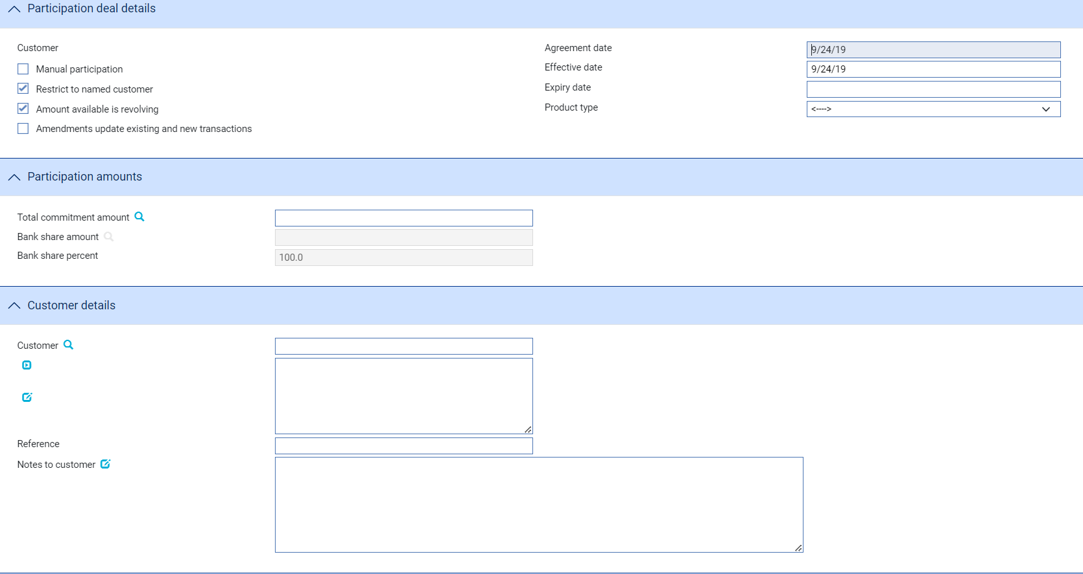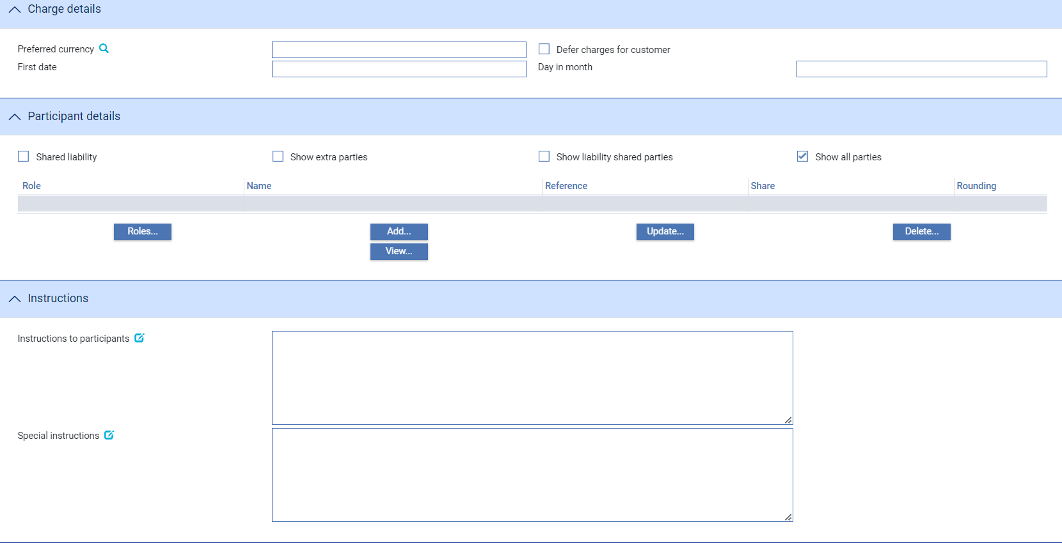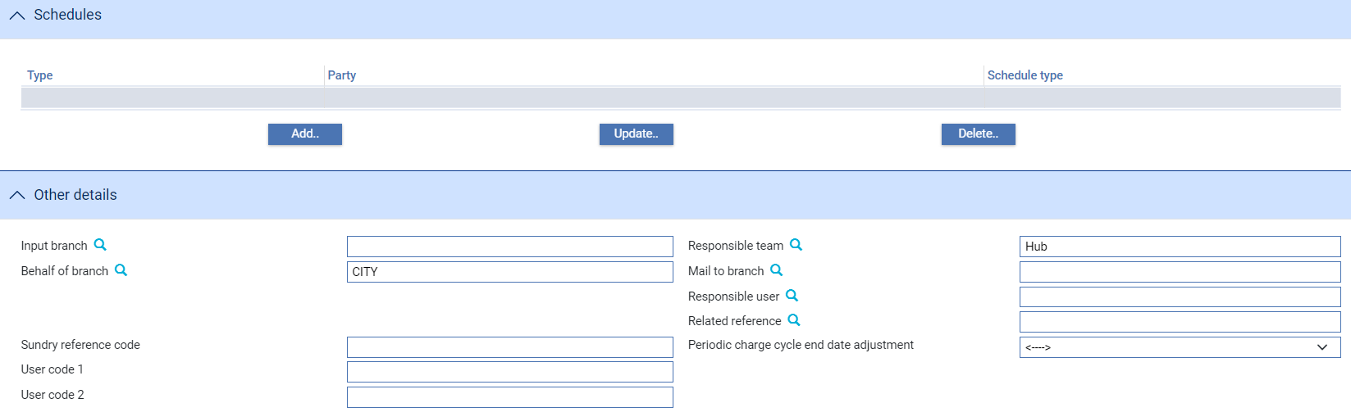

The Create event enables you to enter full details of a new participation deal. To initiate a participation deal, in the Masters window, select the Team and Behalf of branch and use the drop-down list in the New Masters pane to select 'Participation Deal', then click **New**. The system creates a Create event at either a Log step or Input step. Depending on how your system is configured, panes and fields available in log steps can be tailored for each data capture step. See the *SDK - Screen Tailoring Guid*e – Trade Innovation for details.

The window uses the following panes:

* The Participation Deal Details pane (see page 10)
* The Participation Amounts pane (see page 11)
* The Customer Details pane (see page 11)
* The Charge Details pane (see page 13)
* The Participant Details pane (see page 14)
* The Instructions pane (see page 17)
* The Schedules pane (see page 18)
* The Other Details pane (see page 20)

### The Participation Deal Details Pane

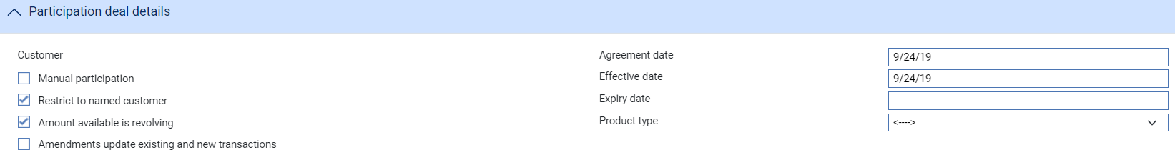

The following table explains what to enter into the fields in the Participation Deal Details pane:

|  | Field | What to Enter |
| --- | --- | --- |
|  | Manual Participation | Check this field if you are creating a manual participation deal. (The default value of this field is set by the system option DefaultManualParticipation; and your bank can hide this field.) |
|  | Restrict to Named Customer | Check this field if the deal is restricted for use with the named customer only. By default, this is checked and the deal is restricted.  You might want to leave this field blank if the participation deal is intended for use with the transactions of several related customers, such as a group of companies. |
|  | Amount Available is Revolving | Check this field if the participation deal is revolving. In a revolving participation deal, the commitment amount available is increased when participated transactions are paid, cancelled, or expired, or the amount of the transaction is decreased. This is achieved by the relevant event in the participated transaction creating a subsidiary Drawdown/Revolve Commit Amt event to increase the available amount of the participation deal.  By default, this field is not checked and the deal is not revolving.   1. It is recommended that you set the deal to be revolving if you anticipate transferring the balance of a participated loan. |
|  | Amendments Update Existing and New Transactions | Check this field if amendments to the participation deal are to be carried over to existing participated transactions as well as new ones. |
|  | Agreement Date | The date that the participation deal was created. The system uses today's processing date as the default. |
|  | Effective Date | The date from which the participation deal can be used. This must be before the Expiry Date, and may be a past date. The system uses today's processing date as the default. |
|  | Expiry Date | The date that the participation deal expires. After this date, this deal cannot be used for new participations. This must be after the Effective Date.  The date entered here is used as the default for participants' release dates when participant details are entered. |
|  | Product Type | If your bank has set up product types for participation deals, select the appropriate one from the drop-down list in this field. Depending on how your system has been configured, this field may be mandatory. |

### The Participation Amounts Pane

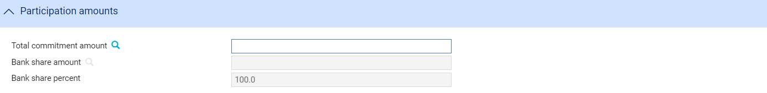

The total commitment amount is mandatory. This figure is the total amount that can be participated. It is used to calculate the commitment amounts for each participant. The total value of all transactions using this participation deal cannot exceed this amount.

The Bank Share Amount and Bank Share Percent fields are calculated when all other participants' shares have been entered. These show the amount and percentage remaining after all the other participant's shares have been deducted from the total commitment amount. These figures be zero if the deal is 100% participated by other banks. You can use the Refresh button to update the fields manually.

### The Customer Details Pane

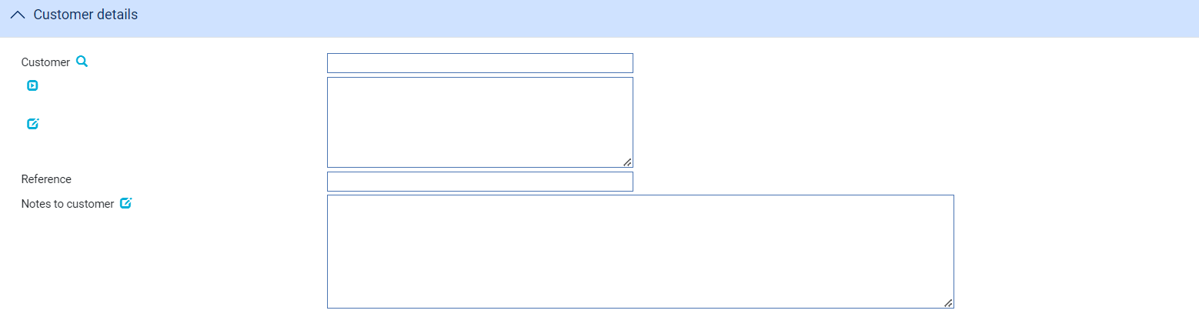

The following table explains what to enter into the fields in the Customer pane:

|  | Field | What to Enter |
| --- | --- | --- |
|  | Customer | The customer to whom the participation deal relates. |
|  | Programme | Enabled if the selected customer has one or more Supply Chain Finance Programmes. You may filter for, or enter a programme identifier which is then linked to the participation deal. |
|  | Reference | The customer's reference number for the participation deal. |
|  | Notes to Customer | Any information to be included on documents that are sent to the customer. |

### The Charge Details Pane



The following table explains what to enter into the fields in the Charge Details pane:

|  |  |
| --- | --- |
| Field | What to Enter |
| Preferred Currency | The currency in which the customer's charges will be debited. Typically, you would set this to your local currency. If you leave this field blank, the system uses the customer charge currency defined in the product options. |
| Defer Charges for Customer | Check this field if the charges are to be deferred. By default, this is not checked and the charges are not deferred. |
| First Date | The date when periodic charges are first taken. After this first date the charges are taken according to the frequency on the charge schedule and the Day in Month entered in the next field. For example:  Today is 12th October  The charge schedule is set up for monthly charging  The charge schedule specifies that charges are taken in arrears  You specify 14th October in this field and 16 for the Day In Month  Therefore, the system will take the first charge on 14th October, and thereafter on 16th November, 16th December, and so on |
|  | Alternatively:  Today is 12th October  The charge schedule is set up for monthly charging  The charge schedule specifies that charges are taken in advance  You specify 14th October in this field and 16 for the Day In Month  Therefore, the system will take the first charge on 12th October, the second charge on 14th October, and thereafter on 16th November, 16th December, and so on  If you leave this blank, the system will use the date calculated by the charge schedule.  Any periodic charges for participants will use these dates unless you override the dates (using the Release Items|Charges link - see the Common Facilities User Guide – Trade Innovation for instructions). |
| Day in Month | The day in each month when periodic charges are to be debited. |

### The Participant Details Pane

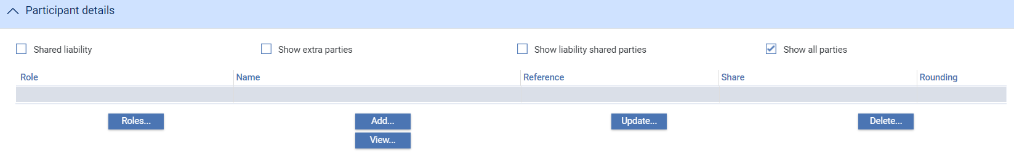

The Participant Details pane is used to enter details of the participants. To define a new participant click **Add**.

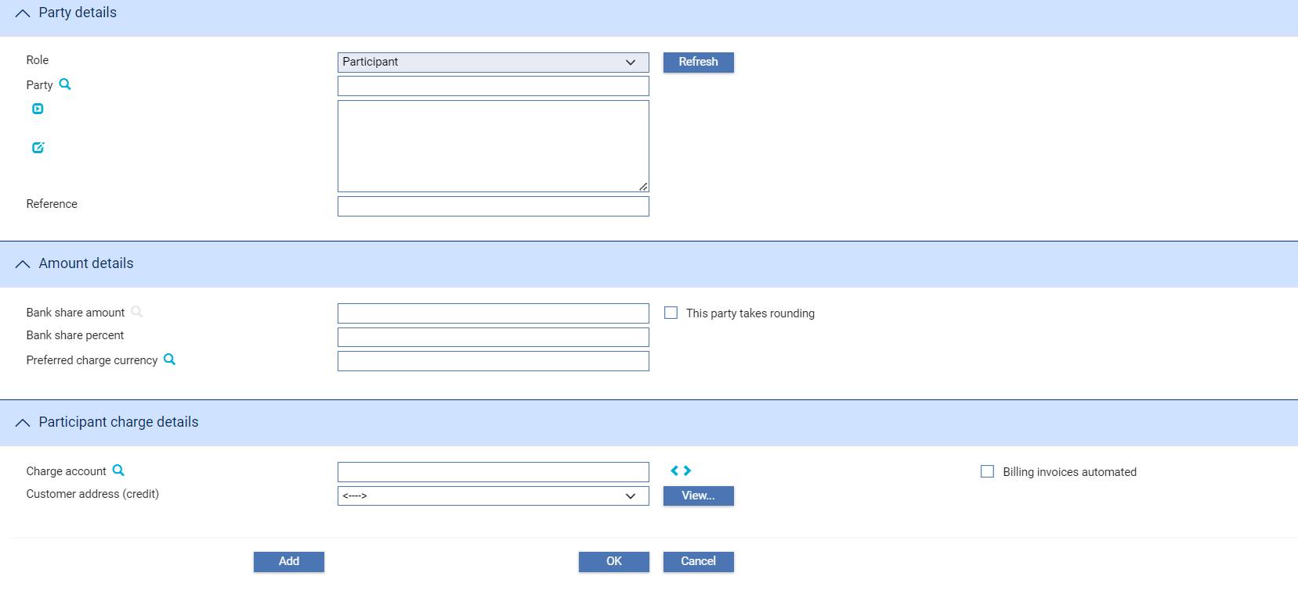

Use the fields in the Party Details pane to identify the participant and their role in the transaction. Use the reference field to enter their reference for the transaction, if you know it.

The Participant's Start Date and Participant's Release Date fields allow you to define the period for which the participant will be involved in the deal. The transaction's effective date is used as the default for the first field; and the transaction's expiry date, if it has been entered, is used as the default for the second field.

Use the fields in the Amount Details pane to identify the party's share in the deal, either as an amount or as a percentage. The Preferred Charge Currency field can be used to specify the currency in which charges will be credited to this participant. If you leave this field blank, the system uses the customer charge currency defined in the product options.

If the participants' shares in the deal add up to 100%, one of the participants must be nominated to take rounding. This is done checking the This Party Takes Rounding field against the relevant party.

If the participants' shares in the deal add up to less than 100%, your bank, as the managing bank, automatically takes any rounding amounts if no other party is specified as doing so.

For manual participation deals, the amount allocated to participants must equal the total commitment amount for the transaction.

When the system option 'UseBillingChargeGroups' is set, the section Participant charge details appears in the add or edit window for Participants’ Maintain Party Details pane of the Participation Create and Amend events.

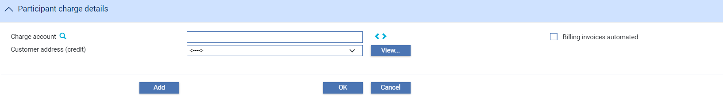

The Participant charge details section has facility to add or edit instructions. The **<>** button toggles between the account field present originally and the settlement field as shown in the section Billing charge data for Participants.

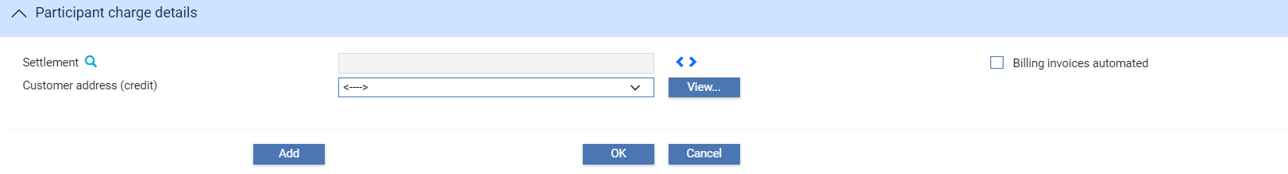

|  |  |
| --- | --- |
| Field | Description |
| Charge account | Account to be used for the billing charge |
| Settlement | Shows details of settlement instructions not by account. This will show details such as nostro/vostro account, account with beneficiary or intermediary bank including the bank itself. |
| Billing invoices automated | Flag used to indicate whether the invoices for charges generated by the transaction are automatically produced or not. |
| Customer address | The charge payee’s prime address. The dropdown list allows an alternative address to be selected. This list excludes the customer’s prime and SWIFT address types. |

Select the settlement instructions by using the Search option beside the label that brings the user to the Master settlement instructions.

Billing settlement templates configured in System Tailoring can be used when adding billing customers as participants that do not settle via account.

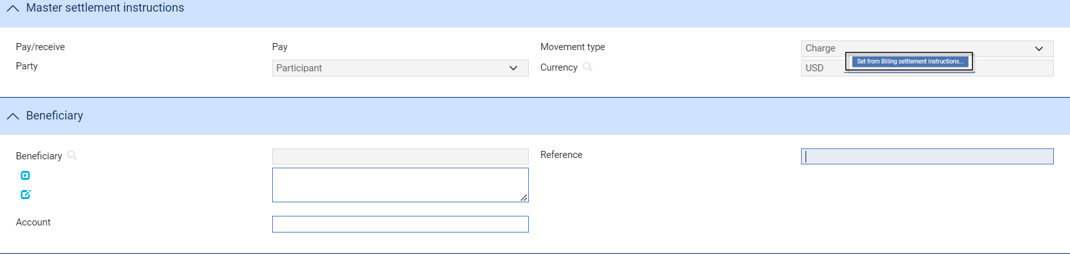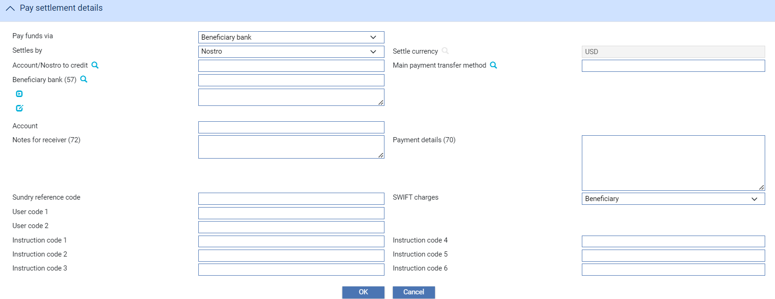

The **‘**Set from Billing settlement instructions’ button opens a browser to allow the user to select a billing settlement instruction template which sets the details of the master settlement instructions. The templates are shown based on the currency selected. Note that the user still has the option to set the billing settlement instructions manually.

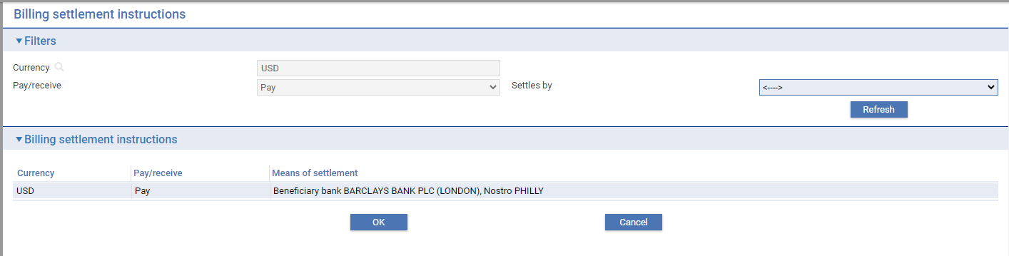

Once the billing settlement instructions are set up, they serve as the master settlement instructions for the participant charge in the Billing settlement event or the Payment received event if the customer is a billing or invoicing customer, respectively.

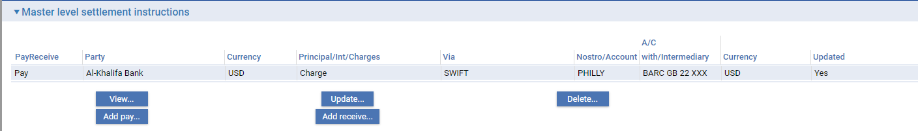

Once you have entered details of the participant, they are listed in the Participant Details pane, where they can be amended or deleted in the usual way.

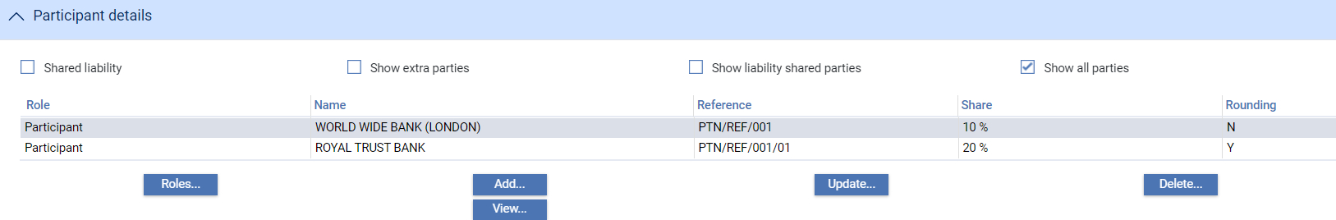

See the Common Facilities User Guide - *Trade Innovation* for instructions on using the New Role button to create a new party role.

### The Instructions Pane

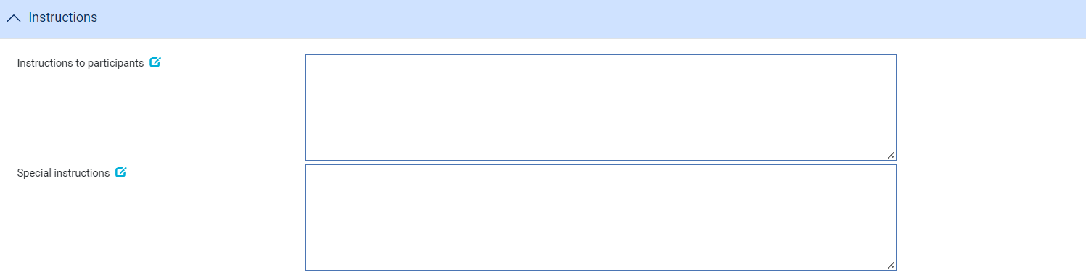

Use the Instructions to Participants field to record any instructions to be included on documents that are sent to participants, and the Special Instructions field to enter any special instructions regarding the participation deal, in addition to those relating to the information already given in the other input fields. You can read these instructions when associating this participation deal with a participated transaction.

### The Schedules Pane

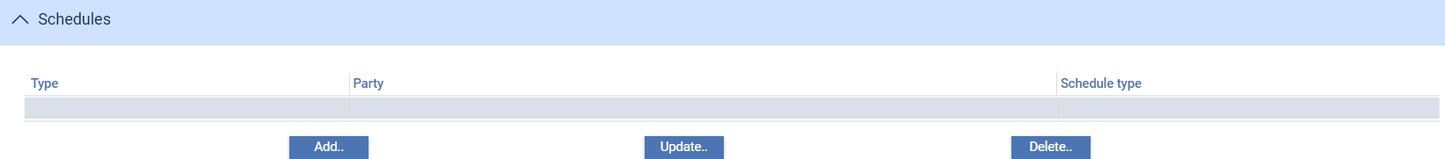

The Schedules pane allows you to add participants' charges to the deal. When you click **Add**, the system lists all the charge types set up on your system.

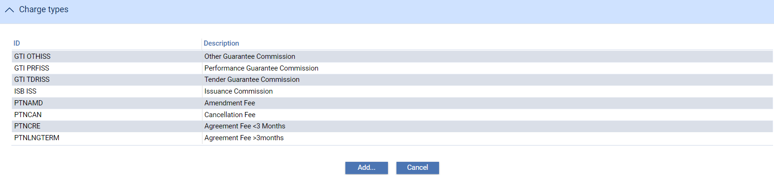

To add a charge to the deal, highlight it and click **Add**.

Select the participating party, then define the schedule for the charge - see the Common Facilities User Guide – Trade Innovation for instructions.

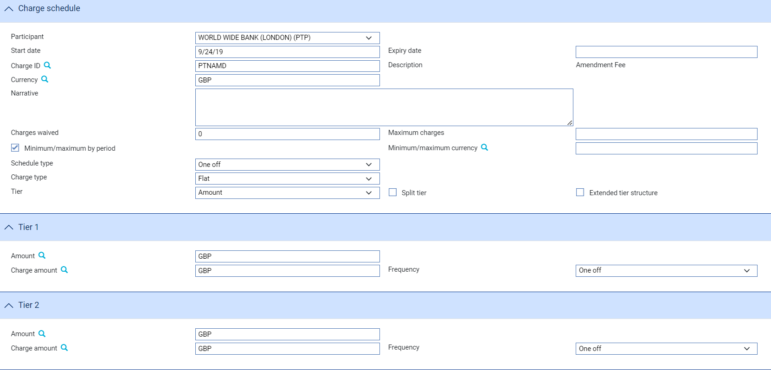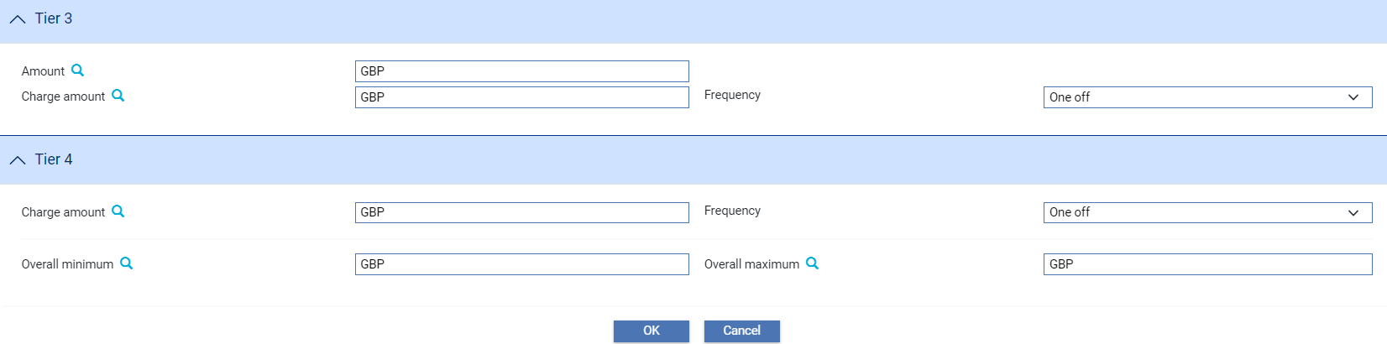

Once you have completed input, the charge is listed in the Schedules pane, and you can amend or delete it in the usual way.

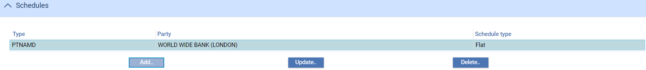

### The Other Details Pane

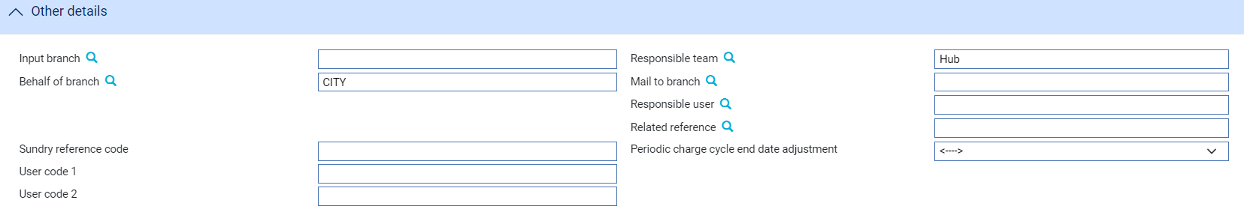

The following table explains what to enter into the fields in the Other Details pane. This pane may also contain some additional fields defined by your bank:

|  |  |
| --- | --- |
| Field | What to Enter |
| Input Branch | The input branch for the transaction. The input branch is set from the either :   * the accounting branch from the user’s team, or * the transaction branch for user if the user has a default transaction branch or is locked to a specific branch, or * a branch associated with the user where the user can enter transactions for several branches for a team |
| Behalf Of Branch | The behalf of branch for the transaction as entered by the user or set from the incoming SWIFT or gateway message. The behalf of branch determines the parameter sets that are to be used to generate charges, documents, postings, etc. during transaction processing. The branch can be changed to any other branch within the same main banking entity that shares the same parameter sets. |
| Sundry Ref Code /User Code 1/ User Code 2 | You may use these fields to enter values for analysis purposes. Your bank will have devised its own system for using these fields. |
| Responsible Team | The team that has overall responsibility for the master e.g. as the system defaults the responsible team when creating the transaction as follows:   * Manual – set from team creating the transaction * Gateway – set from the team specified on the incoming message (if present and valid) otherwise to the team to which the transaction is assigned through workflow allocation based on the behalf of branch * SWIFT – set to the team to which the transaction is assigned through workflow allocation based on the behalf of branch   It can be changed, if required, to either the team associated with the primary customer, default team for the product or the user’s current team. |
| Mail to Branch | The mail to branch can be set to any branch within the main banking entity of the behalf of branch. |
| Responsible User | A user that has responsibility for the master e.g. as the contact to resolve any queries or issues regarding the master and associated events. This can be any user assigned to the responsible team. |
| Related Reference | the system reference for the related transaction. The transaction identified here must be in the same currency as the participation deal, and cannot have already been participated. |
| Periodic charge cycle end date adjustment | Select what happens when a periodic charge cycle end date falls on a non-business/working day. See the *System Tailoring User Guide – Trade Innovation* for more information. |

## Participating a Transaction

When participating a transaction you can either select an existing participation deal or set up a new participation deal for use with this transaction only. This is done from within the Party List pane.

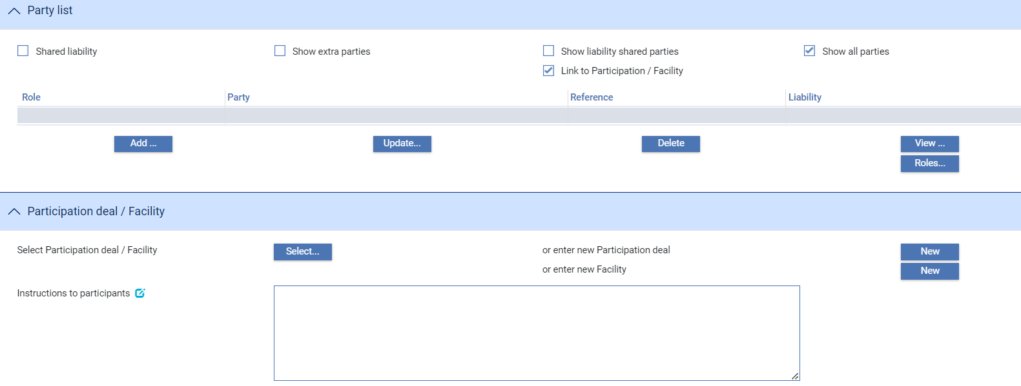

1. The **Select** button is only available if the current user is assigned the following ‘Common functions’ in their User role:

* Export credit facility
* Participation deal select

See the *Security Guide – Trade Innovation* for instructions on creating user roles.

If you wish a transaction to be participated, check the Participated field and then click **Refresh**. The Participation Deal pane is displayed. Use the Instructions to Participants field to record any instructions to be included on documents that are sent to participants.

To create a new participation deal click **New**. The system opens a Create event (see page 7) for you to enter details of the new participation deal.

To select an existing participation deal click **Select**.

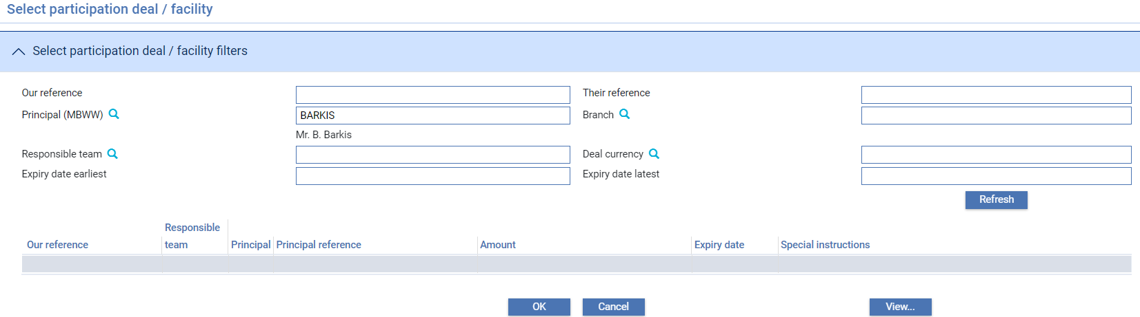

Enter the reference for the participation deal, if you know it; or use the filter fields to display participation deals set up for the customer. Then click **Refresh**.

The system lists all participation deals that match the criteria entered. To see full details of a participation deal, select it and click **View**.

Highlight the deal to be attached to the transaction and click **OK**. The system will issue a warning if any of the following apply:

* The expiry date of the participation deal is before the expiry date or maturity date of the transaction
* The participated amount in this transaction exceeds the total commitment amount available under the participation deal
* The effective date of the participation deal is later than today's date

An error message is issued if the principal party on the transaction is not the same as the customer defined on the participation deal, if the Restrict to Named Customer field is checked on the participation deal.

Once you have selected a participation deal, a Remove button is present in the Participation Deal pane, which removes the participation deal from the transaction.

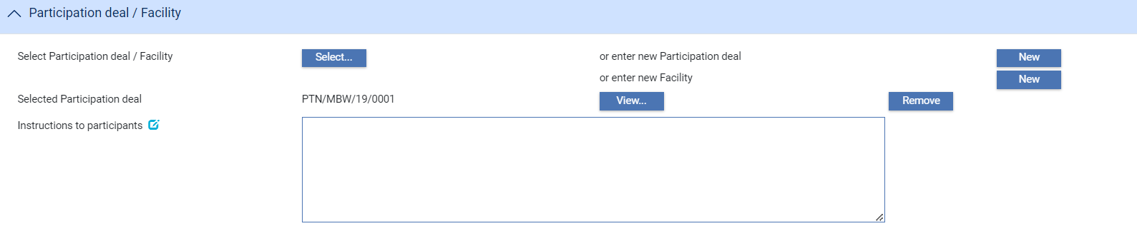

Participants' names and details are added automatically to a transaction's party list when you attach an existing participation deal to it, or when you finish creating a new participation deal from within that transaction. They are identified with the role of 'Participant', and their share of the transaction is indicated in the Liability column of the Party List.

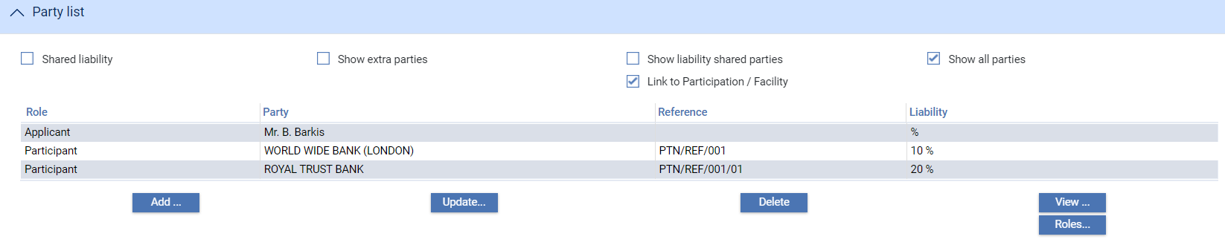

For financing transactions that can be linked to export credit agency facilities, or Supply Chain Finance transactions that are established under a Programme, additional functionality is present that allows you to link the transaction to a facility. The Participated field has the label 'Link to Participation/Facility' and checking it displays a Participation Deal/Facility pane.

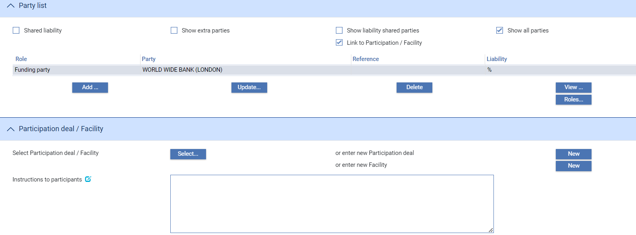

You can use the buttons in this pane to select a participation deal or an export credit agency facility; or to set up a new deal or facility.

1. You cannot link a transaction to a participation deal and an export credit agency facility; you must choose one or the other.

You cannot link an SCF Programme specific participation to a Trade transaction (e.g. Letters of credit, non SCF specific invoice financing etc.).

See the Export Credit Agency Facility User Guide – Trade Innovation for instructions on linking financing transactions to export credit agency facilities. Supply Chain Finance User Guide – Trade Innovation for instructions on linking invoice financing transactions to participation deals.

Security Guide – Trade Innovation for instructions on creating user roles.

## The Master Summary Window For Participation Deals

Once you have created a participation deal, the system will display the basic details of that deal using the Master Summary window.

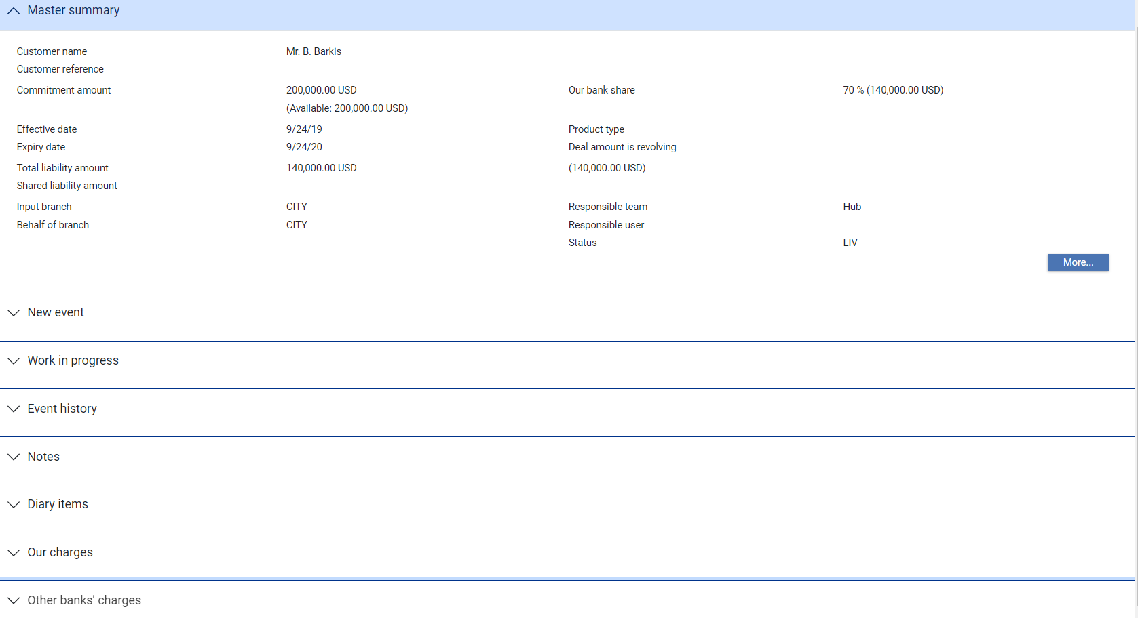

The Related Master link allows you to access details of the participated transaction linked to the participation deal.

For more information on how the various panes and buttons in this window work see the Common Facilities User Guide – Trade Innovation.

## The Master Summary Window for Participated Transactions

The Master Summary window for a transaction will indicate whether it is participated.

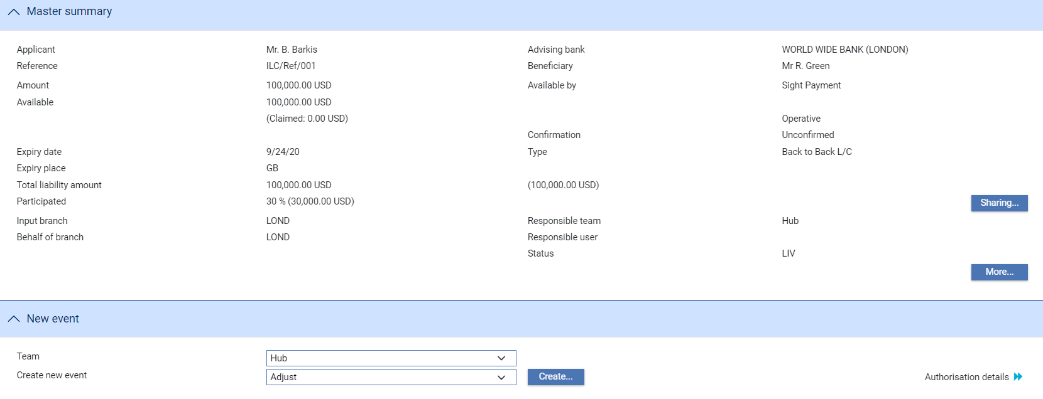

The Sharing button displays a window which shows details of the participants and their share.

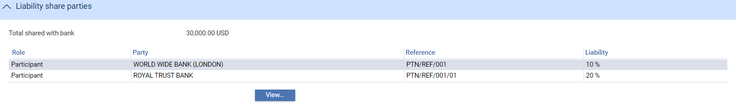

# Making Changes to a Participation Deal

This chapter explains how to use the system as the managing bank to make changes to a participation deal. It also explains how drawdowns affect the available amount of a participated deal.

## Amendments

A participation deal can be amended using an Amend event (see page 19) at any time between the release of the Create event and book-off. Amendments may result from a request by any of the participants to alter their agreement, or from a need to increase the total commitment amount or change the expiry date. Accounting entries and changes to the master record as a result of the amendment are carried out as soon as the Amend event has been released.

An amendment to a participation deal may have an effect on any transactions using it. The participated transactions will be affected by changes such as the following:

* Adding new participants
* Deleting participants
* Changing one or more participants' shares

When the Amend event to the participation is released, any such changes are applied to the participated transactions by the automatic creation of a Maintain Liability event for each affected transaction. This event generates postings to handle any reversals and rebooking of liability and charges required.

The Amend event allows you to make changes to most information relating to a participation deal, including those items that can be expected to change most frequently. If you need to alter any information that cannot be changed using the Amend event, you can use the Adjust event (see page 21).

Note that Amend is an exclusive event; you cannot start another event for a master while an Amend event is in process against it.

### Postings

When details of participants' shares are added, deleted, or changed, the system needs to reverse postings that have already been made in order to adjust the liability figures. This is achieved using reversal postings.

When you set up posting definitions, you can specify that the posting is a reversal by checking the Reversal field. If you check this, some of the other fields in the definition are not available.

Postings made for funds movements and charges are not affected.

See the System Tailoring User Guide – Trade Innovation for setting up posting definitions and for the restrictions on reversal postings, and the Business Reference Guide –Trade Innovation for examples of reversal postings.

### Amendments and Charges

The following table describes the effect on participation charges of adding, updating or removing participants from a participation deal:

|  |  |  |
| --- | --- | --- |
| Type of Charge | Action Taken | Results |
| Periodic in advance | Add participant | The charge is calculated from the date of the amendment to the end of the charge period.  Set the PartnPerdChgFromEffectiveDate system option to Yes to allow participant periodic charges to be calculated from either the participation effective date or the amendment date when adding participants in the Maintain Liability event for guarantees or import, export or standby letters of credit; or the Amend event for a participation deal. Otherwise the participant periodic charges will be calculated from the start date of the current charge period.   1. If the participation effective date is before the start date of the current charge cycle, then the start date of the current charge cycle will be used for calculations of participant periodic charge, even when the PartnPerdChgFromEffectiveDate system option is set to ‘Yes’. |
|  | Delete participant | The charge is reclaimed from the date of the amendment to the end of the charge period. |
| Update participant | The charge is recalculated to work out the increase or decrease from the date of the amendment to the end of the charge period. If the charge amount decreases, the extra amount is reclaimed. |
| Periodic in arrears | Add participant | The charge is accrued from the date of the amendment to the end of the charge period.  Set the PartnPerdChgFromEffectiveDate system option to Yes to allow participant periodic charges to be calculated from either the participation effective date or the amendment date when adding participants in the Maintain Liability event for standby letters of credit or the Amend event for a participation deal; otherwise the participant periodic charges will be calculated from the Start date of the current charge period.   1. If the Participation Effective date is before the start date of the current charge cycle, then the start date of the current charge cycle will be used for calculations of participant periodic charge even when the PartnPerdChgFromEffectiveDate system option is set to ‘Yes’. |
| Delete participant | Charge accrual is stopped. The participant receives the charge up to the date of the amendment only. |
| Update participant | Charge accrual is recalculated The charge is recalculated to work out the increase or decrease due to or from the participant. |
| Non-periodic | Add participant | The charge is calculated for the whole charge period. |
| Delete participant | The whole charge is reclaimed. |
| Update participant | The charge is recalculated to work out the increase or decrease over the whole charge period. |

## Amending a Participation Deal

To amend a participation deal, with the appropriate master record open, in the Master Summary window select 'Amend' from the Create New Event drop-down list and click **Create**. The system opens the event at either a Log step or Input step. Depending on how your system is configured, panes and fields available in log steps can be tailored for each data capture step. See the *SDK - Screen Tailoring Guide – Trade Innovation* for details.

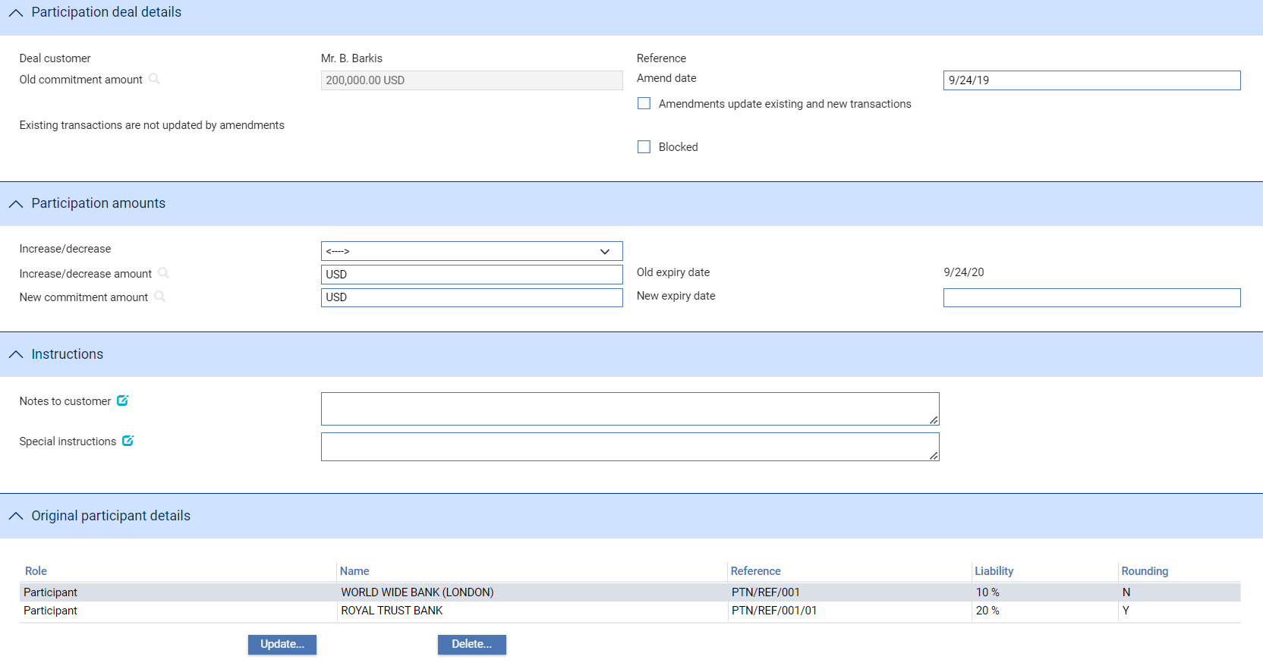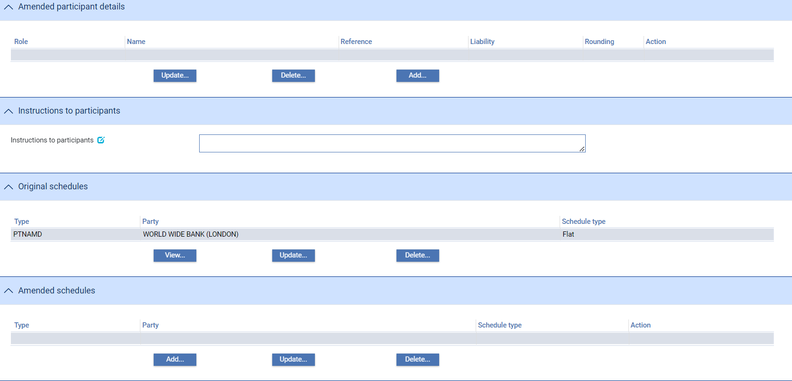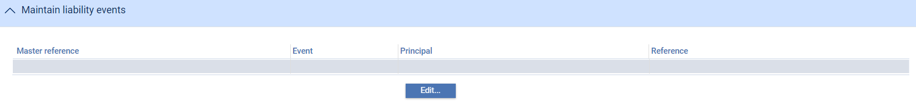

The window displays information on the existing values for the participation deal that can be changed, and provides fields in which you can enter new values.

Use the Amend Date field to enter the date of the amendment.

Check the Amendments Apply Only To New Participated Transactions field if the amendment is to affect only future participated transactions that use this participation deal; otherwise the amendment is applied to existing deals also. If you check this field, the amendment will update both existing and new transactions associated with the participation deal using a subsidiary Maintain Liability event; if you leave it unchecked, existing transactions will not be affected and the amendment will apply only to transactions associated with the participation deal after the Amend event has completed.

Use the fields in the Participation Amounts pane to amend the amount of the participation deal. You can either use the Increase/Decrease field to select whether the change involves an increase or a decrease, then use the Increase/Decrease Amount to enter the value of the increase/decrease. When you click **Refresh**, the system calculates the amended amount and displays it in the New Commitment Amount field.

Alternatively just type the new amount into the New Commitment Amount field.

The Original Participant Details pane lists details of the current parties to the participated deal. You can select and amend or delete these details in the usual way. The changes are displayed in the Amended Participant Details pane. The Original Participant Details pane list does not change. You can also add new participant details to the transaction.

Similarly, the Original Schedules pane lists details of the current participants' charges. You can select and amend or delete these details in the usual way. The changes are displayed in the Amended Schedules pane. The Original Schedules pane list does not change. You can also add new charge schedules to the transaction using the Amended Schedules pane.

The Instructions to Participants pane can be used to enter any instructions to be included in documents sent to participants.

The Maintain Liability Events pane lists all the Maintain Liability events created as a result of this Amend event. A Maintain Liability event is automatically created for each transaction associated with this deal, provided that both of the following apply:

* The Amendments Update Existing and New Transactions field is currently checked. If this field is not check, none of the changes you make will affect existing transactions; they will only take effect for new transactions that use this participation deal
* The Amend event alters one or more participants' amount or percentage share

These Maintain Liability events are created on release of the Amend event.

You can view a Maintain Liability event by selecting it and clicking **Edit**.

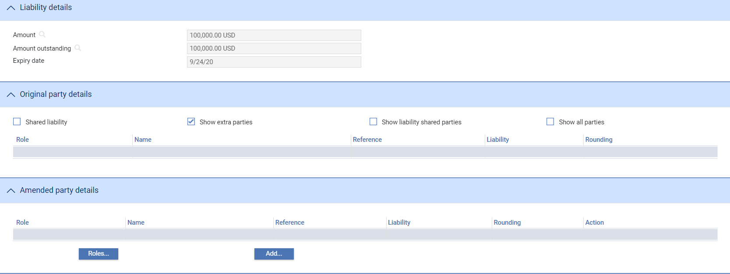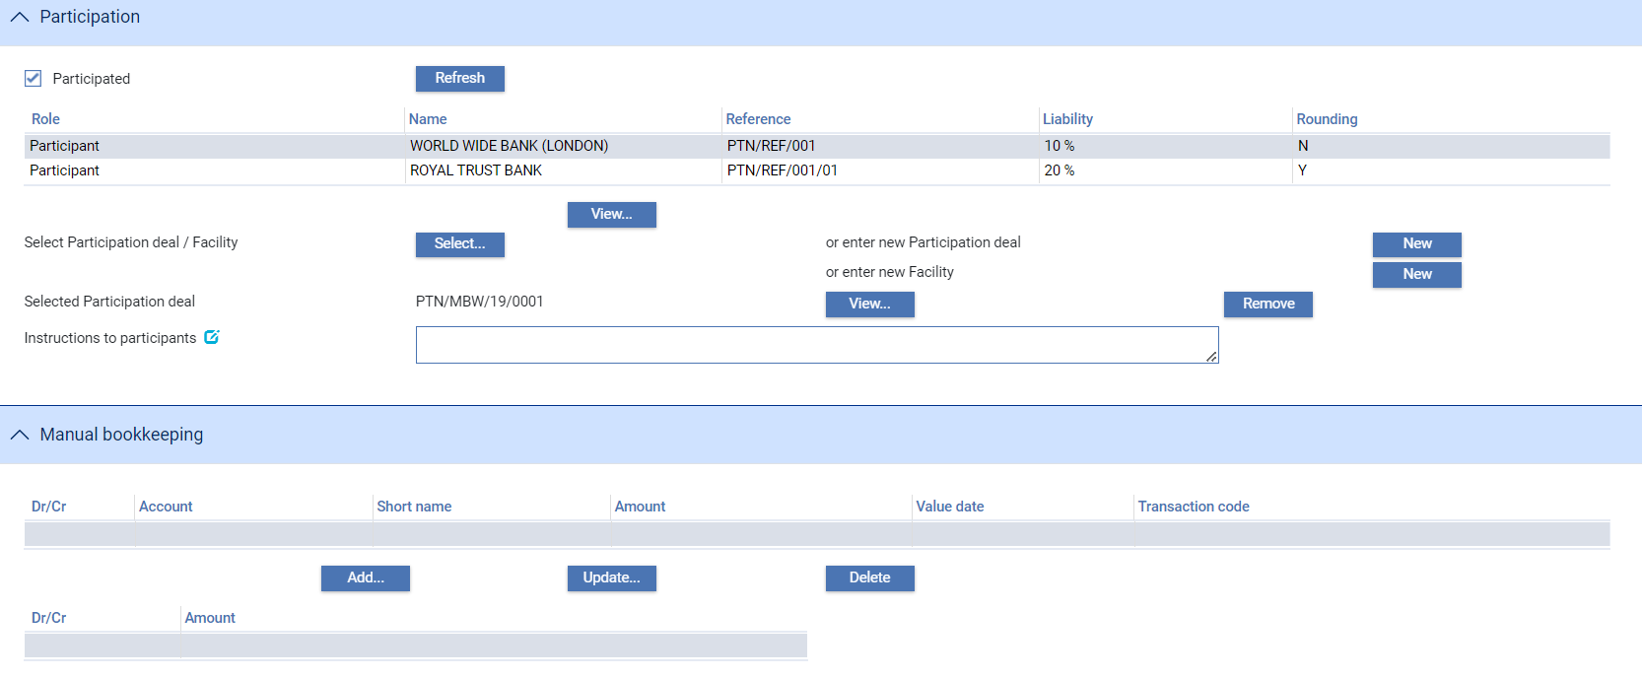

You cannot alter the details of this event that are displayed on the Input window. However, you can edit charges, settlements, clauses, and documents using the links at the side of the window in the usual way.

## Making Adjustments to the Master Record

The functionality of the Amend event allows you to make changes to a sub-set of the information relating to a participation deal. The system includes an Adjust event, which contains additional functionality to allow you to make changes to all the information recorded for a participation deal, with the exception of your bank's reference number for the deal, and the status of a participation deal's master record.

The Adjust event is designed to allow you to make changes where you need to alter details but do not need to notify other parties.

Once you have initiated an adjustment event, the system will prevent you from opening any other event for the participation deal until the adjustment event has completed. If you attempt to open an adjustment event while another event for the master is in progress, the system will warn you of the fact and prompt you to abort the adjustment event. Unless you are attempting to make an adjustment to allow the pre-existing event to complete, you should abort the adjustment event and wait until the pre-existing event has completed before attempting the adjustment event again. If you continue with the adjustment event, then the system will prevent any further work on the pre-existing event until the adjustment event has completed.

This functionally is intended to allow you to correct mistakes, and should be used cautiously. If you make any changes using this functionality, you should ensure that the proper reconciliations are carried out.

To adjust a participation deal, with the appropriate master record open, in the Master Summary window select 'Adjust' from the Create New Event drop-down list and click **Create**. The system opens the event at either a Log step or Input step. Depending on how your system is configured, panes and fields available in log steps can be tailored for each data capture step. See the *SDK - Screen Tailoring Guide – Trade Innovation* for details.

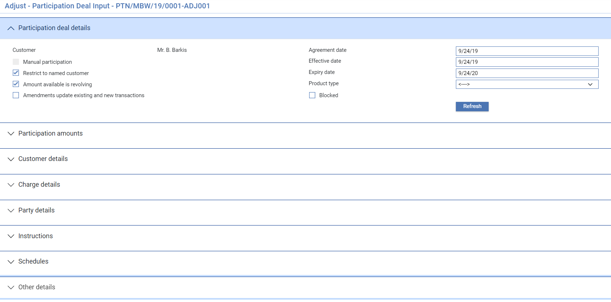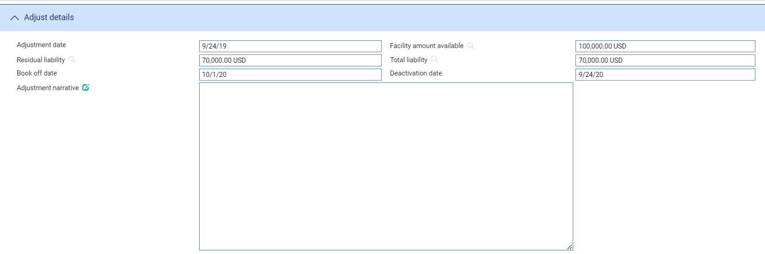

The system displays information already entered for the deal, which you can overtype.

Use the Amendments Update Existing and New Transactions field to indicate whether the adjustment is to affect existing transactions or not. If you check this field, the adjustment will update both existing and new transactions associated with the participation deal; if you leave it unchecked, existing transactions will not be affected and the adjustment will apply only to transactions associated with the participation deal after the Adjust event has completed.

An Adjust Details pane provides additional fields. The following table lists these and explains what to enter into them:

| Field | What it Shows |
| --- | --- |
| Adjustment Date | The date the adjustment was made. This defaults to today's date. |
| Commitment Amount Available | The commitment amount available is an aggregate amount based upon all the related transactions which have used this participation deal. The system adds together the amounts on these masters and subtracts this total from the participation deal commitment amount to arrive at the commitment amount available. |
| Residual Liability | The system displays the current residual liability amount for the participation deal. If the Adjust event has postings set up for it, then the amount you enter here should reflect the residual liability amount before those postings take effect. The postings generated for the event will then reduce or increase the residual liability amount.  If no postings are set up for the Adjust event, then enter here the residual liability amount after the Adjust event has completed |
| Total Liability | The system displays the current liability amount for the participation deal. If the Adjust event has postings set up for it, then the amount you enter here should reflect the liability amount before those postings take effect. The postings generated for the event will then reduce or increase the liability amount.  If no postings are set up for the Adjust event, then enter here the liability amount after the Adjust event has completed |
| Book Off Date | The system displays the participation deal's book-off date, which you can amend. The system will then book off the deal when the new book-off date is reached. |
| Deactivation Date | The system displays the date on which the participation deal will become inactive (after its expiry date and any days grace period has elapsed). You can amend this date. |
| Adjustment Narrative | Identify the changes made and the reasons they were made. |

## Changes to the Available Amount

A participation deal is for a defined amount. The amount actually available at any time will vary as more transactions are participated in, or the amount of a transaction changes. For example:

* The available amount decreases when a new participated transaction is issued, or when a transaction is amended to increase its value
* On revolving participation deals, the available amount increases when a transaction is amended to decrease its value, or when it is paid, cancelled, or expired

These changes in the available amount are handled using a Drawdown/Revolve Commit Amt event. Drawdown/Revolve Commit Amt events are created in one of two ways:

* As subsidiary events against the participation deal master when you click **OK** or **Pend** on the Input window of such an event that changes the participation deal's available amount
* For manual participation deals, they are created manually

### Handling Changes Automatically

For non-manual participation deals, Drawdown/Revolve Commit Amt events are created automatically as subsidiary events against the participation deal master when you click **OK** or **Pend** on the Input window of an event that changes the participation deal's available amount. The drawdown or revolve takes effect on the participation deal, changing the amount available, when the main event that created it is released.

These subsidiary events are listed in the Work in Progress pane in the participation deal's Master Summary window.



Selecting the Drawdown/Revolve Commit Amt and clicking **View** shows details of the drawdown.

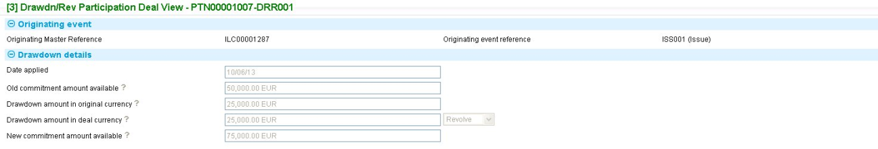

The Old Commitment Amount Available represents the amount available under the participation deal before this drawdown or revolve was applied to it. The New Commitment Amount Available is the amount after this drawdown or revolve was applied.

The following table shows the events in the life-cycle of a participated transaction that produce a Drawdown/Revolve Commit Amt event automatically:

| Product | Event | Revolve | Drawdown |
| --- | --- | --- | --- |
| Letters of credit, standby letters of credit, guarantees | Issue (for import transactions) and Advise (for export transactions) | No | Yes, if using an existing participation deal |
|  | Amend, Beneficiary Response | For decrease in transaction value | For increase in transaction value or reinstatement |
|  |  | For a currency change, this may produce either a Drawdown or a Revolve | |
|  | Cancel, Beneficiary Response | Yes | No |
|  | Expiry | Yes | No |
|  | Payment events | Yes | No |
|  | Maintain Liability | No | Yes, if the transaction is newly participated using an existing deal |
| Standby letters of credit, guarantees | Reduction/Increase | For reduction in transaction value | For increase in transaction value |
|  | Renewal | No | For renewal at original amount |
| Financing | Create | No | Yes, if using an existing deal |
|  | Amend | No | For increase in value of loan |
|  | Repayment (including scheduled repayment) | For repayment of the loan principal | No |
| Clean banker's acceptance | Create | No | Yes, if using an existing participation deal (for acceptance or for acceptance purchased) |
|  | Purchase | No | Yes, if using an existing participation deal (for acceptance purchased) |
|  | Sell | Yes | No |
|  | Early Repay | For the amount repaid | No |
|  | Mature | Yes | No |

## Making Changes Manually

For manual participation deals, Drawdown/Revolve Commit Amt events can be created manually. Your bank will have devised its own procedure for informing the appropriate department when such an event is required, and for providing the necessary information.

In the Master Summary window select 'Drawdown/Revolve Commit Amt' from the Create New Event drop-down list and click **Create**. The system opens the event at either a Log step or Input step. Depending on how your system is configured, panes and fields available in log steps can be tailored for each data capture step. See the *SDK - Screen Tailoring Guide – Trade Innovation* for details.

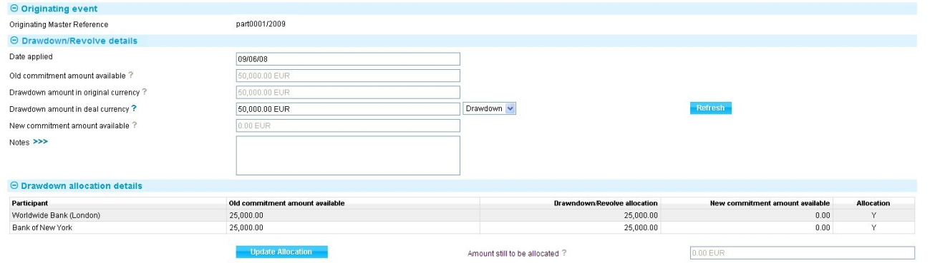

The Old Commitment Amount Available represents the amount available under the participation deal before this drawdown or revolve was applied to it. The New Commitment Amount Available is the amount after this drawdown or revolve was applied.

Use the dropdown list to specify whether you are entering a drawdown or a revolve.

The system uses the current processing date as the default for the date the drawdown or revolve is to be applied, and the current amount available on the participation deal as the drawdown or revolve amount. You can overwrite these values.

The Drawdown Allocation Details pane lists those participants who are affected by the event, showing for each the amount allocated to them, calculated according to their percentage commitment. You can amend this amount by selecting a participant in the list, then clicking **Update Allocation**.

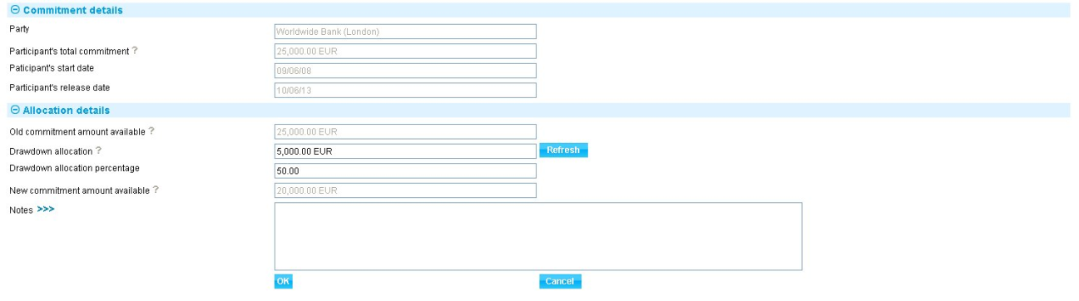

In the window that appears you are able to amend the actual amount allocated to the participant, or the percentage they should receive of this drawdown or revolve. If you change one figure, when you click **Refresh** or **OK**, the system automatically calculates the other.

The Notes field allows you to enter any information to be included on correspondence with the participant about this particular drawdown or revolve.

# Managing Shared Liability

This chapter explains how to use the Maintain Liability event to update participated transactions to take account of changes in the participation deal. You can also use it to participate a transaction that was not previously participated, or to share customer liability.

## Shared Liability

The Maintain Liability event (see page 27) enables participated transactions to be updated to take account of changes in the participation deal. You can also use it to participate a transaction that was not previously participated, or to share customer liability.

Maintain Liability events can be used to participate a transaction of any of the types that can support participation deals; or to share customer liability on a transaction. It can be used with the following trade finance products:

* Import letters of credit, standby letters of credit and guarantees
* Export letters of credit, standby letters of credit and guarantees

In addition, when a participation deal is amended, you can flag the amendment so that it affects existing participated transaction, as well as any new ones that are created (this is done using the Amendments Update Existing and New Transactions field). In such a case a Maintain Liability event is created as a subsidiary event for each participated transaction attached to the participation deal.

You can open this subsidiary event in the usual way.

You cannot use the Maintain Liability event with financing transactions, whether independent or against other transactions. For these, you must make any changes required to the funding or interest for the participants manually, using a Manual Bookkeeping event.

### Postings

When details of participants' shares are added, deleted, or changed, the system needs to reverse postings that have already been made in order to adjust the liability figures. This is achieved using reversal postings. When your bank sets up posting definitions, it can specify that the posting is a reversal by checking the Reversal field.

See the System Tailoring User Guide – Trade Innovation for setting up posting definitions and for the restrictions on reversal postings; and the Business Reference Guide – Trade Innovation for example reversal postings.

Postings made for funds movements and charges may be affected by the system calculating refunds of charges paid in advance to banks who cease to be participants in a participation deal, or who reduce their share.

Your bank may need to obtain refunds of charges paid in advance to banks who cease to be participants in a participation deal, or who reduce their share. (Alternatively, your bank may waive the right to such refunds.) The Maintain Liability event incorporates a manual book-keeping facility to enable you to adjust the charges paid to a participant if their share of the participation changes, and to set up the postings between charge accounts and participants' settlement accounts.

## Entering Shared Liability Details against a Participated Transaction

To create a Maintain Liability event against a participated transaction, in the Master Summary window for the participated transaction select 'Maintain Liability' from the Create New Event drop-down list and click **Create**. The system opens the event at either a Log step or Input step. Depending on how your system is configured, panes and fields available in log steps can be tailored for each data capture step. See the *SDK - Screen Tailoring Guide – Trade Innovation* for details.

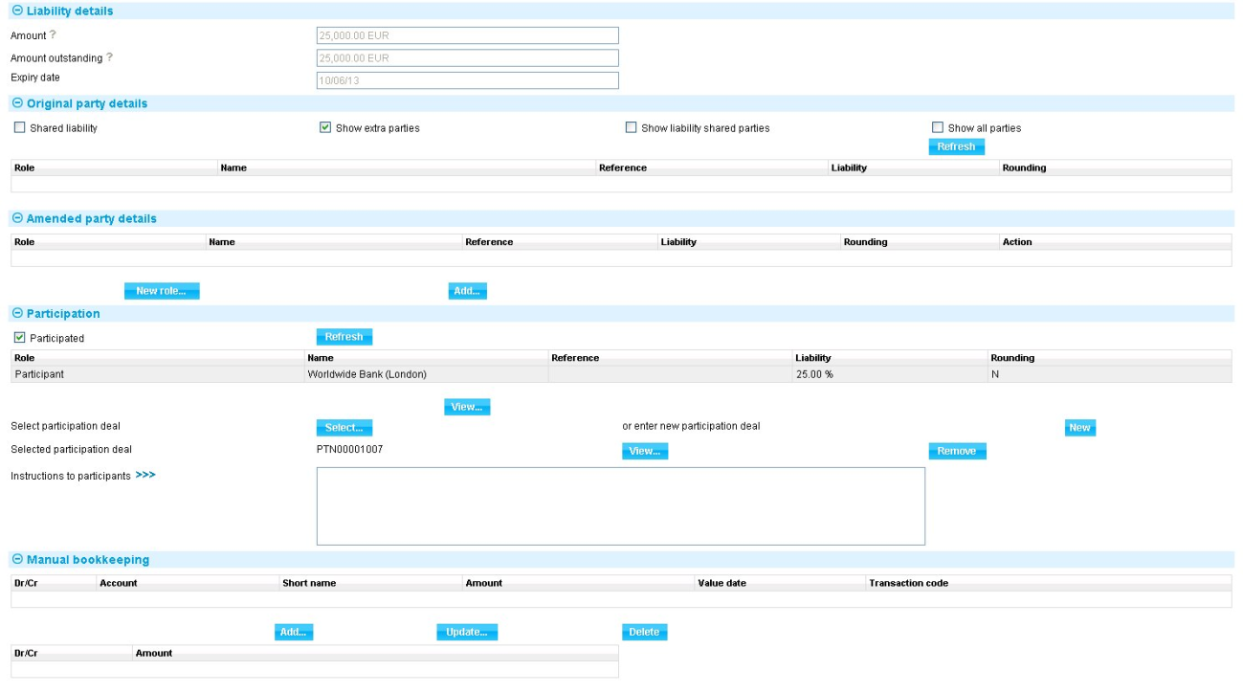

The Liability Details pane shows the amount on the master record for this transaction, the amount of the transaction outstanding and the expiry date of the transaction. You cannot change these.

The Original Party Details pane lists details of the current parties to the participated deal. You can select and amend or delete these details in the usual way. The changes are displayed in the Amended Party Details pane. The Original Party Details pane list does not change. You can also add new participant details to the transaction using the Amended Party Details pane.

The Shared Liability field is checked if there is shared liability on this transaction.

If the transaction is not currently participated, the Participation pane contains buttons that allow to participate a transaction for the first time. Use the Select button to associate the transaction with an existing participation deal, or the New button to create a new participation deal.

The Manual Bookkeeping pane allows you to enter any postings required to support changes you make - for example, to adjust the charges paid to a participant if their share of the participation changes, and to set up the postings between charge accounts and participants' settlement accounts. The functionality is that same as that of the Manual Bookkeeping event, as described in the Common Facilities User Guide – *Trade Innovation.*

# Cancelling a Participation Deal

This chapter explains how to use the system to cancel a participation deal.

## Cancelling Participation Deals

A participation deal can be cancelled at any time after the release of the Create event and before book-off.

When you cancel a participation deal, all untaken periodic charges are automatically calculated up to the next charge date and a Pay Charges event is scheduled for the next close of business, to enable these charges to be taken or billed.

You cannot cancel a participation deal which is currently in use on any active participated transaction. If you wish to cancel a participation deal that is in use, you can amend the transaction(s) in order to remove the participation deal. Alternatively, you can achieve the effect of cancelling the deal by amending it to set all participants' shares in the deal to zero.

## Entering Details of the Cancellation

To cancel a participation deal, with the appropriate master record open, in the Master Summary window select 'Cancel' from the Create New Event drop-down list and click **Create**. The system opens the event at either a Log step or Input step. Depending on how your system is configured, panes and fields available in log steps can be tailored for each data capture step. See the *SDK - Screen Tailoring Guide – Trade Innovation* for details.

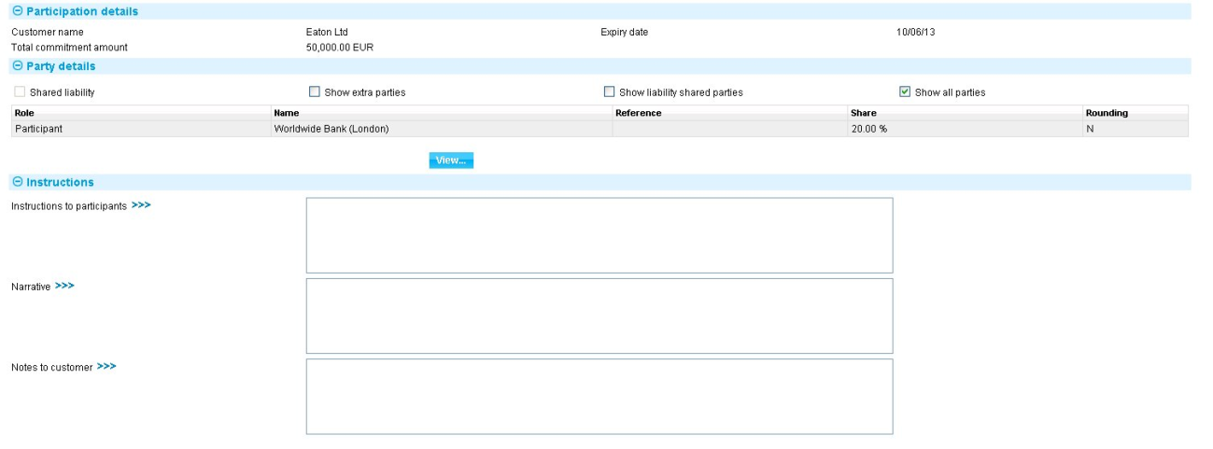

The Participation Details pane shows details of the customer, the expiry date, and the total commitment amount for the participation deal.

The Parties pane shows details of the participants. You can select a participant and click **View** to see full details of that party.

The following table lists the other fields used to cancel a participation deal, and explains what to enter into them:

|  |  |
| --- | --- |
| Field | What to Enter |
| Instructions to Participants | Any instructions to be included on documents that are sent to participants regarding the cancellation. |
| Narrative | The reason for the cancellation. |
| Notes to Customer | Any information to be included on documents to be sent to the customer regarding the cancellation. |